Generated by AI. Be sure to check for accuracy. Meeting notes:
Deal Desk Build-Out and Immediate Impact: Danielle, Bruce, and the team discussed the phased approach to building out the supply chain deal desk, emphasizing the need for immediate impact through a first iteration while awaiting deliverables from ongoing projects, and outlined how future tools and guidelines will support the group’s operations.
Phased Approach to Deal Desk: Danielle described three phases for the deal desk build-out: starting with immediate engagement and contract review, then integrating deliverables from ongoing projects, and finally leveraging technology such as an AI bot for support. Immediate Actions and Contract Attributes: The group agreed to begin by reviewing contracts and identifying high-level attributes such as price changes, admin fee rates, and supplier count to flag contracts needing further review. Timeline and Impact: Danielle noted that the team is signing deals with a contracting timeline potentially extending to September, highlighting the urgency to inject the deal desk into the process for immediate influence.
Growth Project and Opportunity Heat Map: Danielle, Matt, and the team reviewed the growth project’s opportunity heat map, analyzing contract uptake, off-contract spend, and areas for portfolio expansion, with input from Ken and Jim on procurement nuances and benchmarking.
Heat Map Analysis: Danielle explained the opportunity heat map, which visualizes contract uptake and identifies categories with significant off-contract spend, prompting the team to investigate delivery and contract gaps. Portfolio Expansion Opportunities: The team discussed expanding into new categories where Premier currently lacks contract coverage, considering market realities such as suppliers unlikely to join GPO contracts. Procurement and Formulary Challenges: Ken highlighted the extra work required to move spend from off-contract to on-contract, especially in food and pharmacy, due to item master and formulary complexities. Benchmarking Spend Coverage: Jim suggested tracking the percentage of spend covered by awarded suppliers to minimize conversion work and ensure contracts align with member purchasing behaviors.
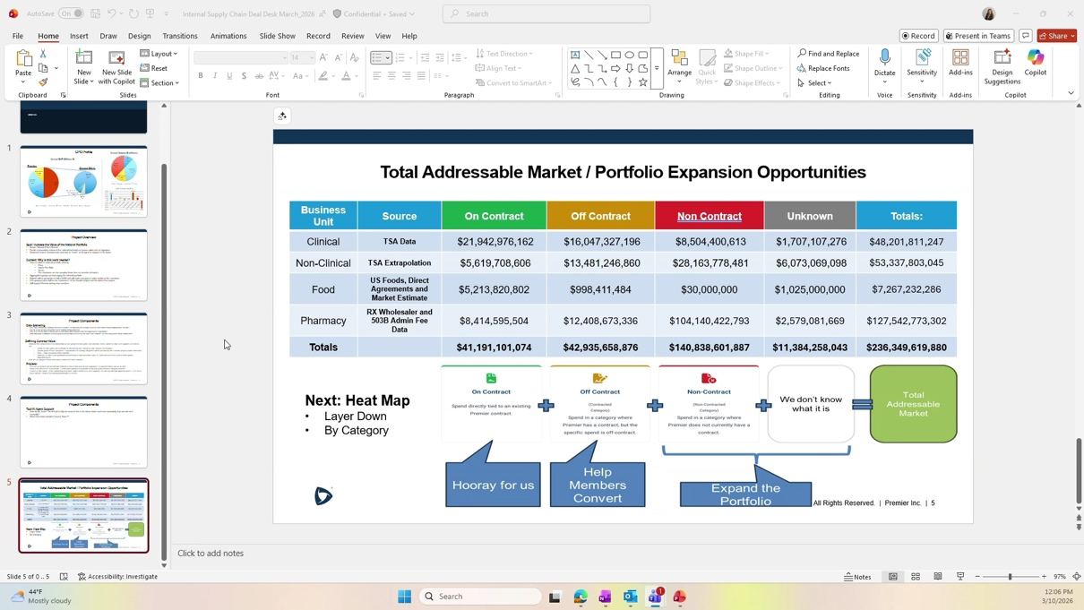
Defining Success and Value in National Contracts: Matthew Shimshock, Danielle, Tyson, and others debated the primary goals for the deal desk—whether to focus on growth, fee optimization, or national contract competitiveness—and discussed the need for clear standards, benchmarking, and proactive guidance for negotiators.
Success Criteria and Problem Statement: Matthew Shimshock raised the question of whether the deal desk’s goal is to increase growth and fees or to make national contracts more competitive, prompting Danielle to clarify that the group’s focus is on improving the value of the national portfolio. Standards and Benchmarking: Tyson and Ken emphasized the importance of establishing clear standards for contract review, using percentiles and benchmarks to define what constitutes a competitive contract, and managing exceptions rather than reviewing all contracts. Timing of Guidance to Negotiators: Tyson discussed the ideal timing for providing feedback to negotiators, suggesting that guidance should be delivered before the RFP stage to influence strategy and outcomes. Visibility and Data Access: Jim and Matt Bossemeyer confirmed that negotiators have access to internal and external benchmarking data, enabling them to assess contract value for most members, though some limitations exist for non-performance group members. Iterative Approach and Exception Management: The team agreed to start with high-level contract attributes and iteratively refine their review process, focusing on exceptions and using tools like the value assurance scorecard and Healthcare IQ benchmarks.
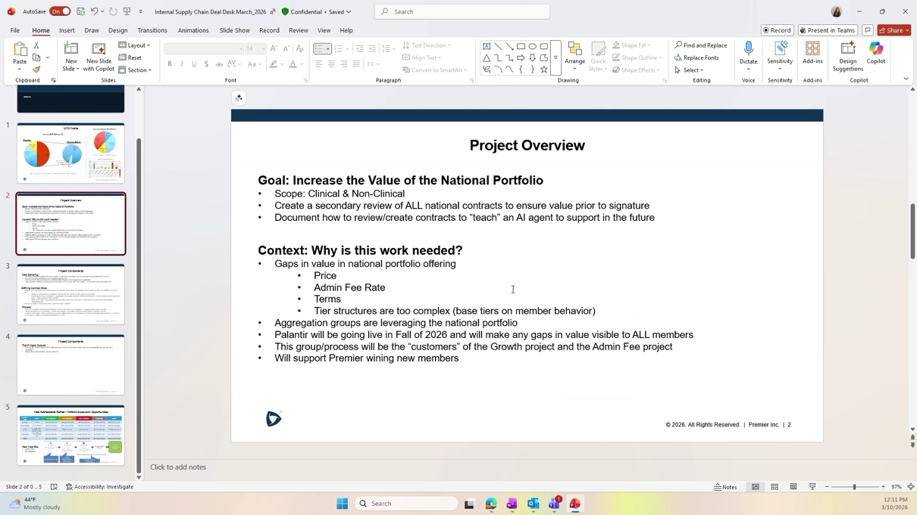
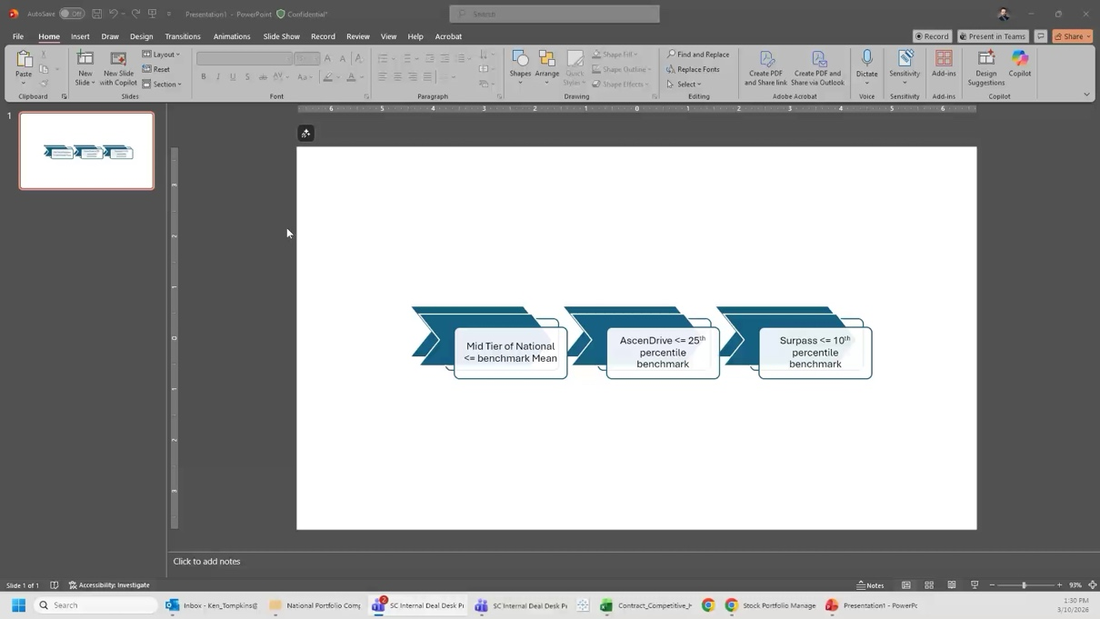
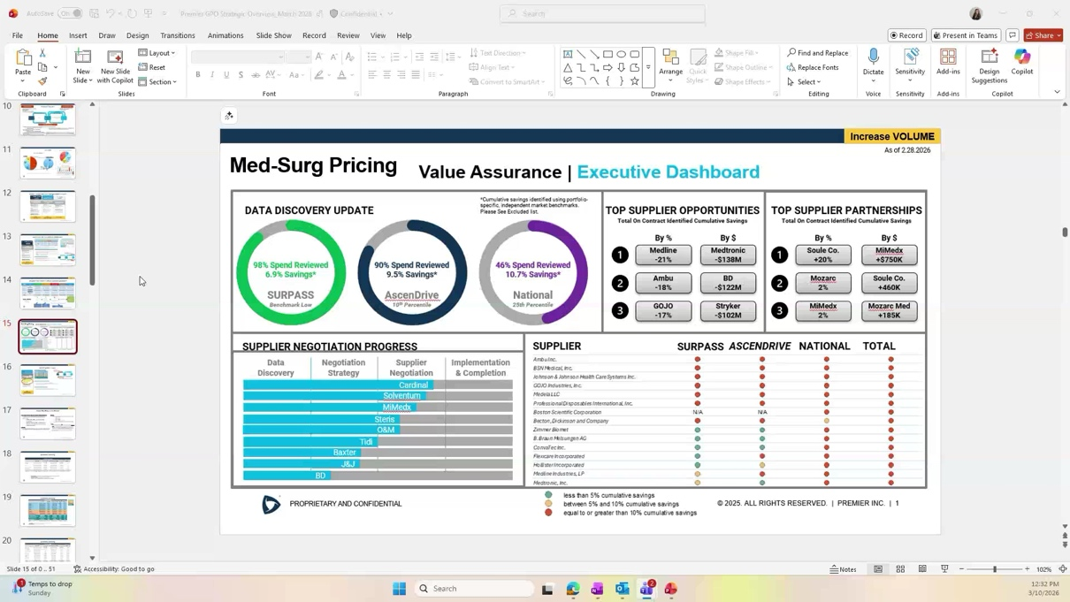
Scenario Modeling and Category Analysis: Matthew Shimshock, Ken, Jim, and Matt Bossemeyer led an exercise to select contract categories for scenario modeling, discussing criteria for value, supplier mix, and benchmarking, and identifying data sources for further analysis.
Category Selection for Analysis: The group chose categories such as PICC and midline access products, incontinence, and ultrasound contrast media for scenario modeling, aiming to establish criteria for value and contract strategy. Supplier Mix and Market Share: Ken and Jim discussed how supplier concentration affects contract strategy, noting that fewer suppliers typically lead to better pricing and easier conversion. Data Availability and Platforms: Matt Bossemeyer confirmed that relevant data is available in the ABI platform and other shared spaces, and Jim planned to reach out to Kyle MacKinnon and Rachel Rollins for visibility into clinical and non-clinical contract tracking. Scenario Modeling Approach: Matthew Shimshock proposed using analytics engines to model outcomes based on supplier mix, benchmarking, and tier selection, allowing the team to proactively define contract strategies.
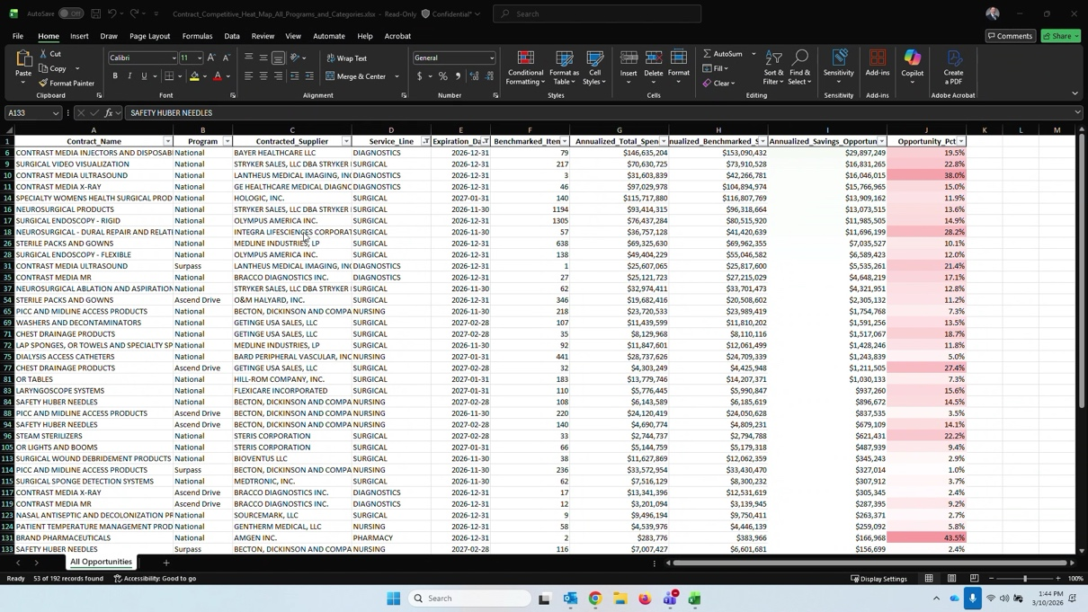
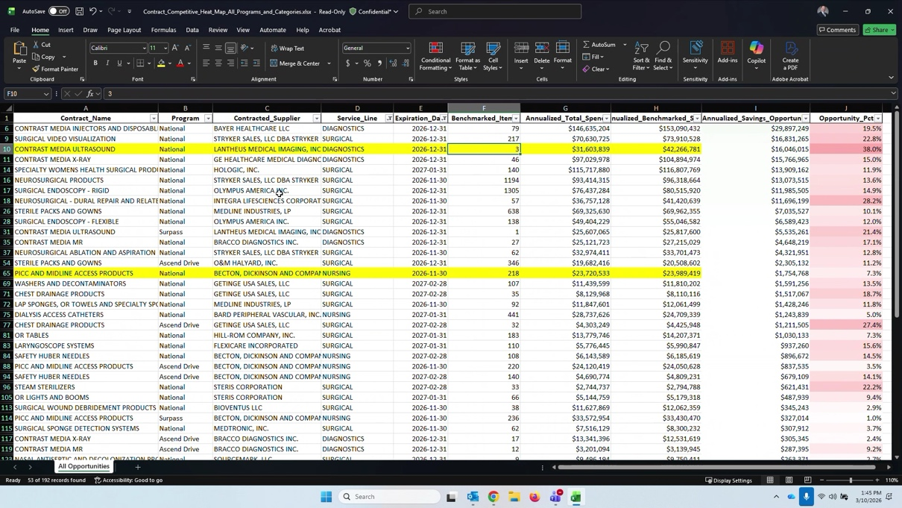
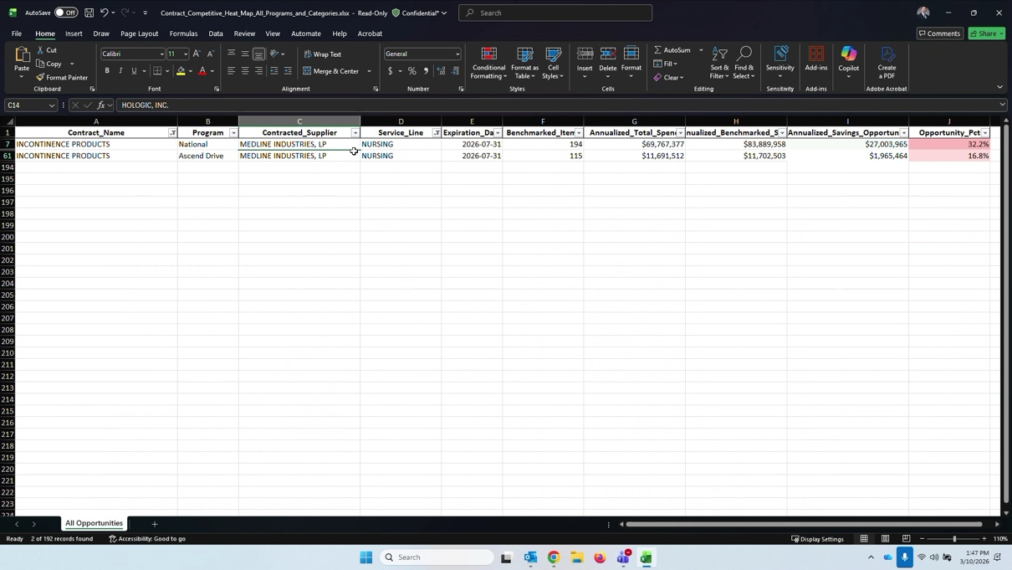
Establishing Contract Review Standards and Exception Process: Tyson, Ken, Danielle, and Matt Bossemeyer discussed the need for clear, proactive standards for contract review, advocating for an exception-based process to streamline approvals and ensure only contracts not meeting defined criteria are escalated to the deal desk.
Exception-Based Review Process: Tyson proposed managing contract reviews by exception, with clear standards allowing most contracts to proceed without manual review, and only those failing to meet criteria being escalated. Standard Setting and Communication: The team discussed the importance of communicating standards to negotiators, using benchmarks such as the 75th percentile for national contracts, and ensuring new data sets like Healthcare IQ are integrated into the process. Value Assurance Scorecard: Danielle and Tyson referenced the value assurance scorecard as a tool for applying standards and tracking contract performance, noting its recent adoption and potential for broader use.


Action Items and Next Steps for Data Visibility: Jim, Danielle, and Matt Bossemeyer identified key action items for gaining visibility into upcoming contracts, including reaching out to Kyle MacKinnon and Rachel Rollins for clinical and non-clinical tracking, and confirmed the existence of shared spaces for contract data.
Data Visibility Action Plan: Jim committed to contacting Kyle MacKinnon for clinical contract tracking and Rachel Rollins for non-clinical/services tracking, aiming to locate shared dashboards or lists for upcoming contracts. Shared Spaces for Contract Data: Danielle confirmed that business units maintain shared spaces for tracking contract work, and Matt Bossemeyer offered to follow up on the location of RFP responses and related data.
Guiding Principles for Sourcing and Supplier Awards: Ken summarized guiding principles for sourcing, advocating for fewer suppliers to achieve better pricing, market share shifts, and higher admin fees, and suggested reversing previous practices of broad supplier awards.
Supplier Award Strategy: Ken recommended that sourcing prioritize fewer supplier awards to drive better pricing, facilitate market share shifts, and secure higher admin fees, contrasting this with past practices of awarding many suppliers. Market Share and Admin Fee Implications: The team discussed how concentrating awards supports conversions and increases admin fees, noting exceptions for single-source or dual-source categories.
Follow-up tasks:
Contract Data Visibility: Reach out to Kyle MacKinnon (clinical) and Rachel Rollins (non-clinical/services) to determine where to access current and upcoming contract data and tracking information. (Jim) Contract Data Visibility: Inform the group once visibility into contract tracking information has been obtained from Kyle MacKinnon and Rachel Rollins. (Jim)

